Jones, Paul Milne (based mainly on Environment and Conservation News 2011)
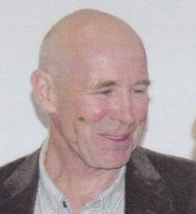
BSc Forestry ANU, graduated 1971. Commenced as Assistant Divisional Forests Officer 1972, worked in Dwellingup Fire Research with George Peet. Later was District Manager at Jarrahdale/Kelmscott and Regional Leader in Manjimup. After CALM was formed in 1985 he was a scientific advisor to the Director of Forests Peter Hewett. In that job for 10 years, he assisted in the development of the timber production strategy and 3 forest region regional plans. He was then in an officer exchange with the Department of Primary Industries and Energy in Canberra. In 1991-2 he was involved in development of the forest management plan for 1994-2003. In 2001 he established the Management Audit Branch of CALM and was its manager. He was then involved in developing the Forest management plan 2004-2013. In 2004 he was acting director of Forests and appointed as Director of Sustainable Forest Management with DEC in 2006. From 2008, he was involved with the Perth Observatory. He retired in 2011, after 40 years’ service with the Forest Department, CALM and DEC.

